**Explore weather trends**

**Extract data**

To extract data I used the following code

*SELECT GD. Year ,*

*GD.Avg_temp as Global_avg_temp,*

*CD.Avg_temp as Barcelona_avg_temp*

*FROM global_data GD*

*LEFT JOIN city_data CD*

*ON GD.Year = CD.Year*

*WHERE*

*CD.Country = ‘Spain’*

*and CD.City = ‘Barcelona’*

*and CD.Avg_temp IS NOT NULL*

I used LEFT JOIN to keep all years from Global data, and remove data before 1750, as I had seen that Global data had data from 1750 until 2015, and Barcelona from 1743 but with empty gaps from 46 – 49.

In addition, as Barcelona do not have data from 2013 on, I kept just data not null in my city with IS NOT NULL statement.

I imported data with Excel, and I had to change dots by commas to be recognized as a number.

**Moving averages**

As seen in the theory, moving averages is very common to identify tendencies and to mitigate big fluctuations.

To calculate moving averages, I created new columns on top of the ones extracted in SQL, to calculate 3-year MA and 10 years MA, we could check as much number of years in the past as we consider, for example, over 3-5-7-10-15 years.

On 3-year moving average, we are going to calculate the arithmetic mean temperature over the previous 3 years, so we need to start from the third year (1752), to be able to have data over the previous 3 years, we can use the AVERAGE() function available in Excel or PROMEDIO() in the Spanish Excel version.

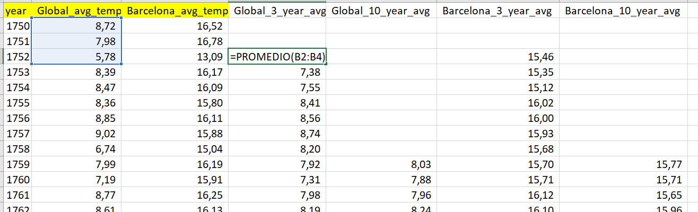 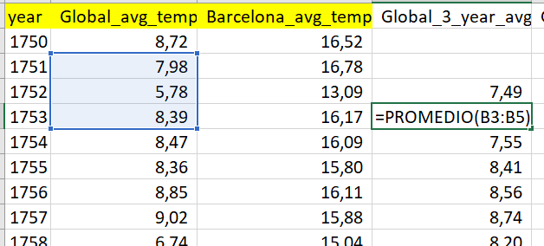

Same for 10-year moving average, in this case calculation will start from the tenth row, to be able to calculate arithmetic mean over the previous 10 years.

To decide moving average winner, I decided the one I can see tendencies easier, looking smooth. Is true that with 10 years we lose a bit of information from first years, as them had big changes, but I kept important trends.

For example, we can still see the fluctuation tendency from 1806 to 1822, but we can see the long-term trend, do not give all detail, as we are seeking averages.

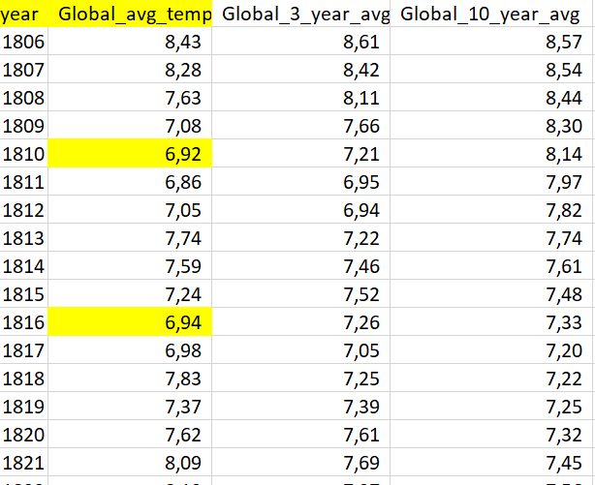

Finally, we can see in a graph a comparison between Barcelona, Spain and global data.

As we can see on the graph climate is going up all over the world and we are presenting the same in Barcelona. We moved one degree up average from 1750 to 2015.

In addition, we can see a different tendency between 1815 and 1823, trends went down in both cases, Barcelona and globally, but was just for a few years, we could search the reasons on history, but is not what concerns us today.

Barcelona is hotter compared to the global average along the time, is constant, has similar trends than global data. To go deeper, I printed the difference from Global temperature versus Barcelona temperature. Barcelona is around 7 – 8.5 degrees over Global temperature average. So, both have a similar trend, not too much variation difference.